1.access records owned by reallows at DB.
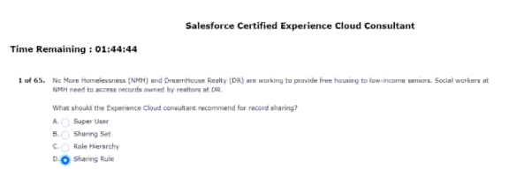
2.Part of a board digital transformation initiative.hV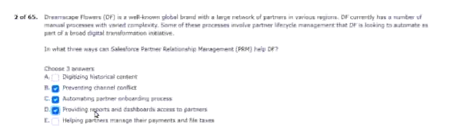
3.can have a ensure integrated experience.
Customers can log in to CK’s site?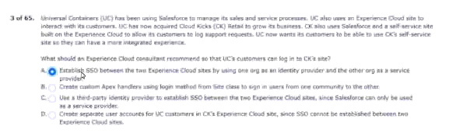
4.public experience cloud site is visible to search manager.
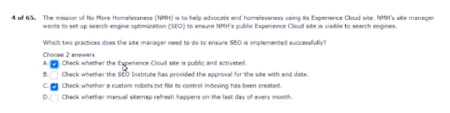

5.through google analytics for experience cloud notes?
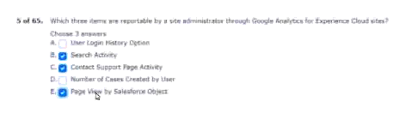
6.and customer community plus license for the customer.
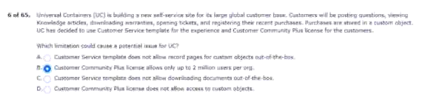
7.including unauthenticated users.
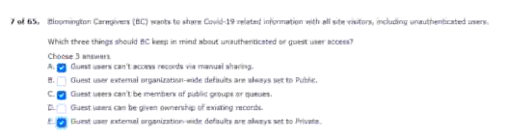
8.that come from autocomplete on search terms.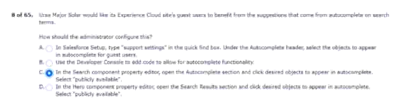
9.low-security B2C customer issues.
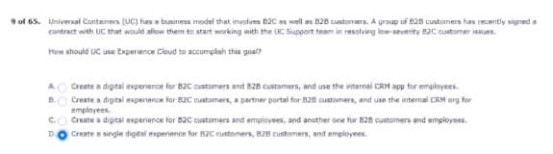
10.customers can see these subscriptions.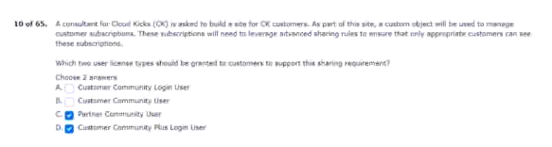.
11.when creating experience cloud users?
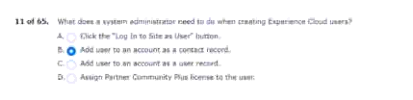
12.page of this product by setting its visibility..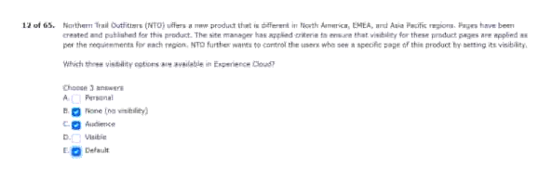
13.partners to the community.
Access to the leads tab.
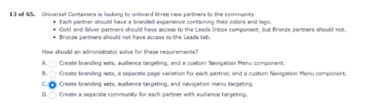
14.knowledge articles available to site users.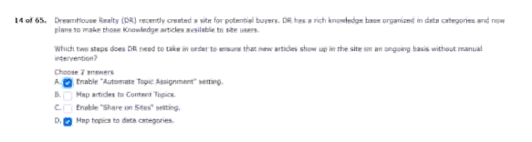
15.on DF’s approach.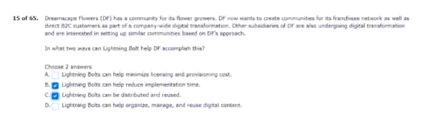
16.are not getting the desired results.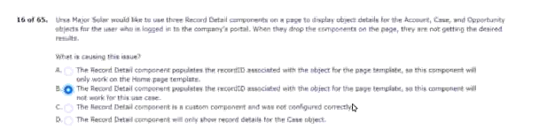
17.must be exposed in the new site.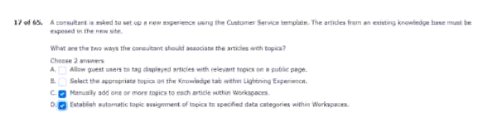
18.what are three valid topic types?
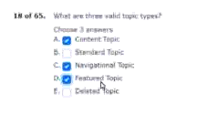
19.to use partner central template.
To meet the requirement?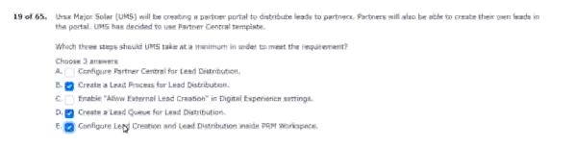

20.on its experience cloud site.
Impact on customer service?
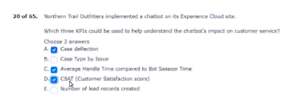
21.trends along with near real time updates
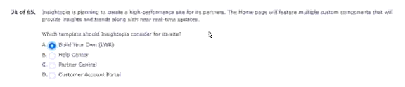
22.that has a partner community license?
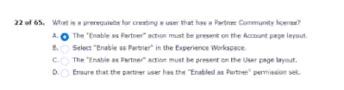
23.records with customers community users?
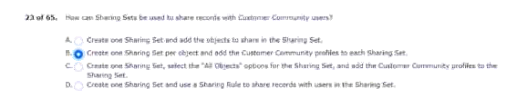
24.be using content delivery network (CDM).
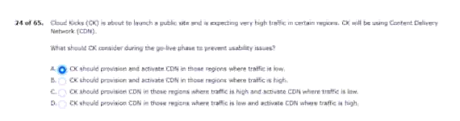

25.the partner users were able to register.
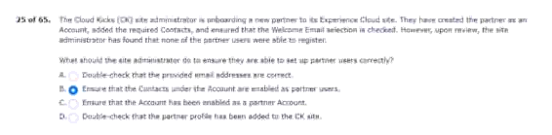
26.for partner employees.
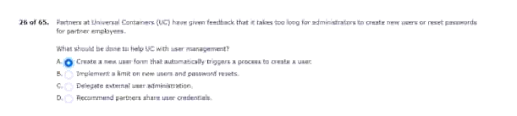
27.of the box features.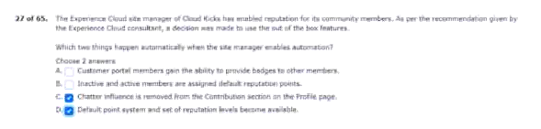
28.that meets the following requirements.
Use for these partner users?
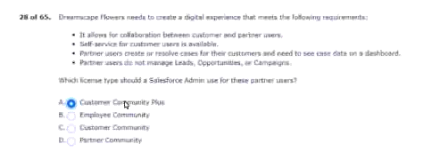
29.has taken on an experience cloud site?
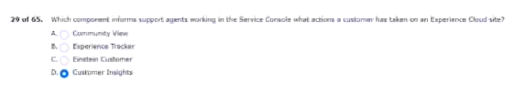

30.an experience cloud site setup?
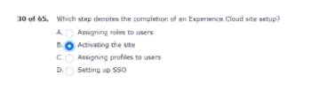
31. Design when a platinum customer is logged in.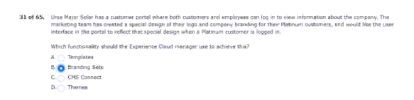
32.that have been assigned to the topics. 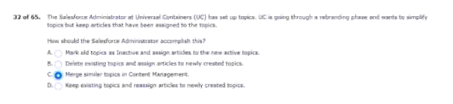
33.an three research work.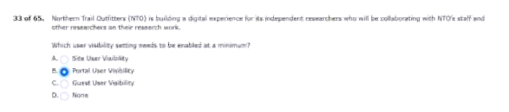
34.via a CMS collection in its customer portal.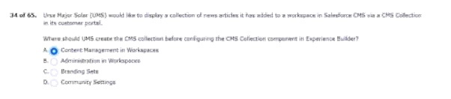

35.unable to view the experience cloud site.
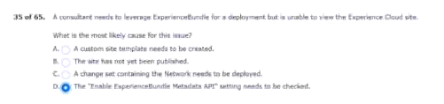
36.which two statements regarding data categories are
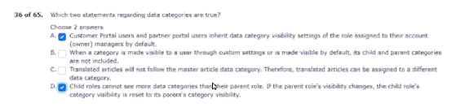
37.when the customer is logged in to the site.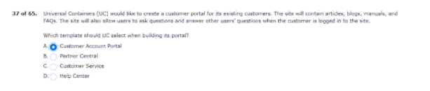
38.experience cloud site however the import feded.
Two reasons for this failure?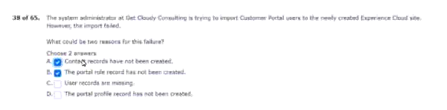
39.in their area as soon as it
consultant recommend for record sharing?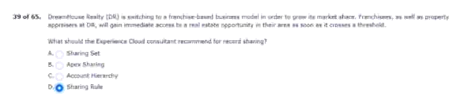

40.not looking to create a placeholder account.
Uses customer community plus license.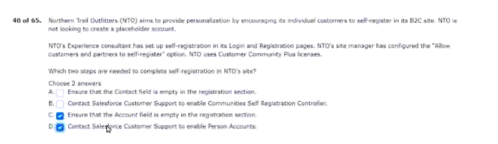
41.a partner community license and a site.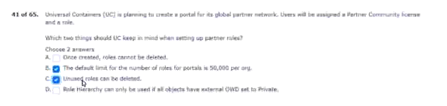
42.workers as well as with ZRS staff.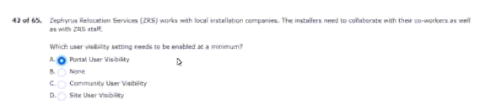
43.customers portal to be vertical.
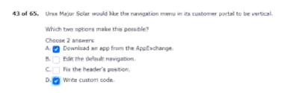
44.manage and FAQs
Select when building its size?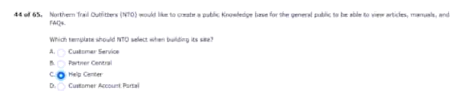
45.should not be shared with partners.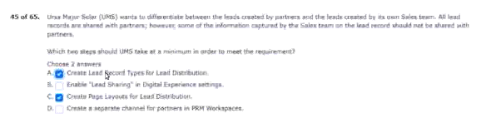

46.lead distribution and deak registration.
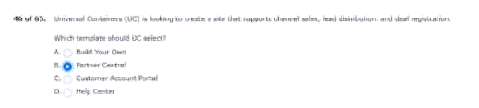
47.for migrating changes between environments
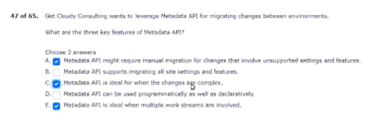
48.with CK is planning to change.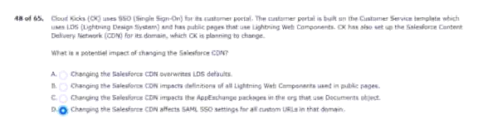

49.and third-party authenticated teams.
Before it is published?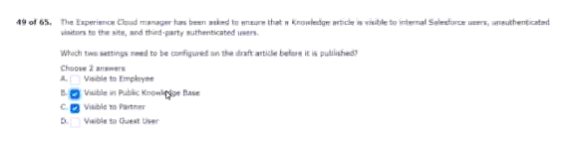
50.with experience cloud site moderation functionality?
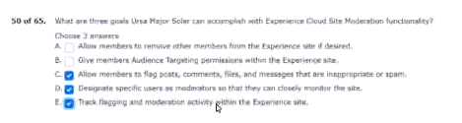

51.chat line with a support agent.
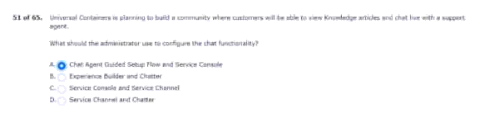
52.standard profiles for external users.
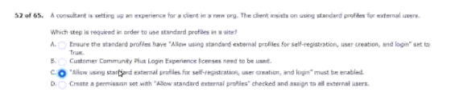
53.agent while browsing the experience cloud site.
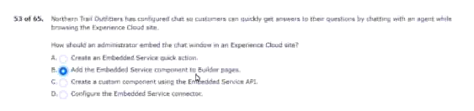
54.is now reaching unmanageable levels.
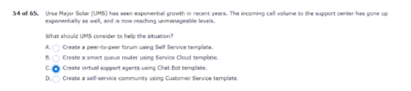
55.installation projects and deals.
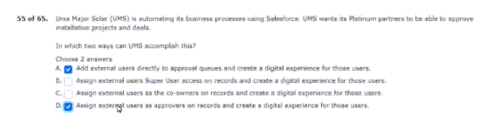

56.for specific components in its portal.
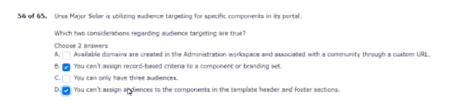
57.for an experience cloud site?
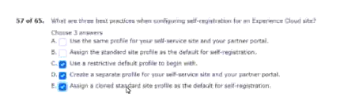

58.use these recommendations during cultivation.
Distribution and projections.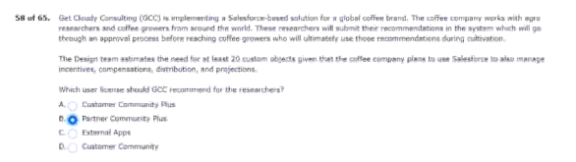
59.has access to more than one site.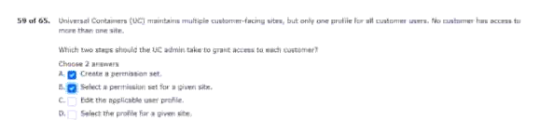
60.but they are getting an error.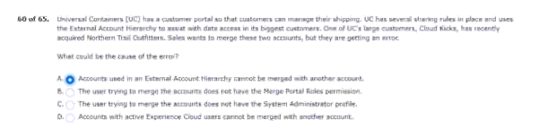

61.participating in any other values activity.
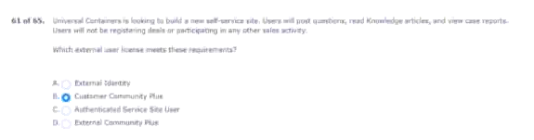

62.user access be supplied?
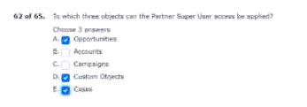
63.for its domain in production environment
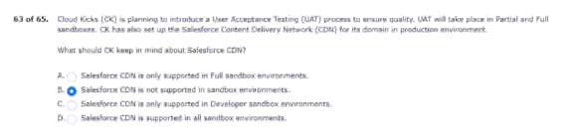
64.when using criteria-based audiences?
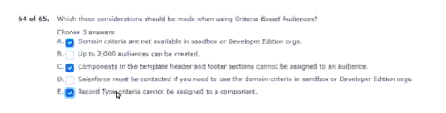
65.link to standard and customer objects.
